IT SYSTEM RESTORE PLAN FOR PENSION ADMINISTRATION COMPANY

1. Introduction

1.1 Purpose
This document outlines the procedures and responsibilities required to restore IT systems and services following a disaster. Its goal is to minimize downtime, prevent data loss, and ensure business continuity.

1.2 Scope
This plan applies to all IT systems, networks, hardware, software, and data managed by [Your Organization Name].

1.3 Key Contacts
Name | Role | Contact Number | Email

12. Dependency Mapping: System Dependency Diagram
The dependency diagram below outlines the relationships and interdependencies between critical systems.
Key Dependencies:
- Network Infrastructure is the foundation for all services.
- Integration Layer connects all systems.
- Financial System (FESTINA) depends on Integration Layer.
- CRM (Salesforce) and Portals depend on Integration and Financial systems.
- BI Layer depends on Financial and Integration systems.
- External Applications primarily interact via the Integration Layer.
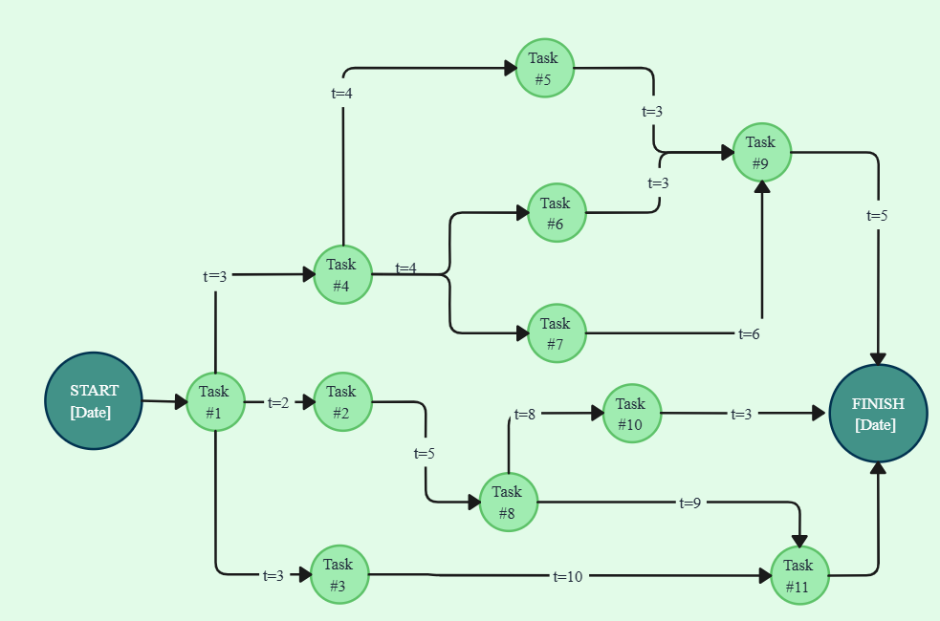
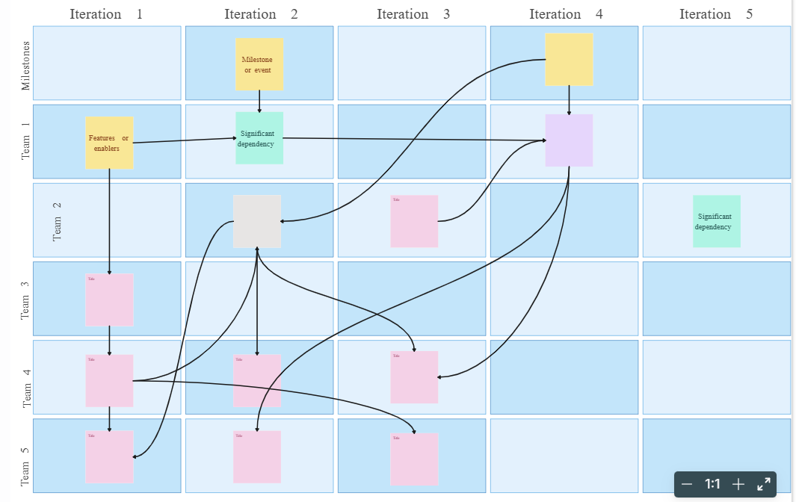

13. Restoration Order: Priority Table
Priority | System Name | Dependency | Estimated Restore Time | Notes
1 | Network Infrastructure | - | 1 hour | Foundation for all systems
2 | Integration Layer (Azure Functions & Service Bus) | Network | 2 hours | Facilitates system-wide communication
3 | Financial System (FESTINA) | Integration Layer | 3 hours | Critical for financial operations
4 | CRM (Salesforce) | Integration Layer | 3 hours | Customer and business workflows
5 | Custom Portals (Employer & Employee) | Integration, Financial | 4 hours | End-user access points
6 | BI Layer | Financial System | 2 hours | Lower priority for reporting
7 | External Applications | Integration Layer | 2 hours | Reconnection to primary services
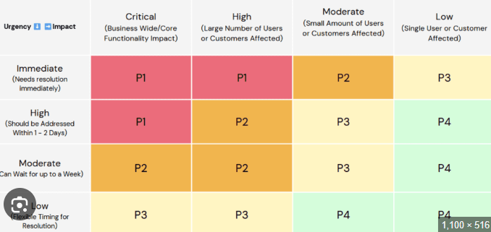

14. Task Interdependencies: Gantt Chart
The Gantt Chart below represents the timeline and sequence of tasks, including dependencies and overlaps.
Example Timeline:
- Day 1: Restore Network Infrastructure
- Day 1–2: Restore Integration Layer (Azure Functions & Service Bus)
- Day 2–3: Restore Financial System (FESTINA)
- Day 3–4: Restore CRM (Salesforce)
- Day 4–5: Restore Custom Portals (Employer & Employee)
- Day 5–6: Restore BI Layer and External Applications

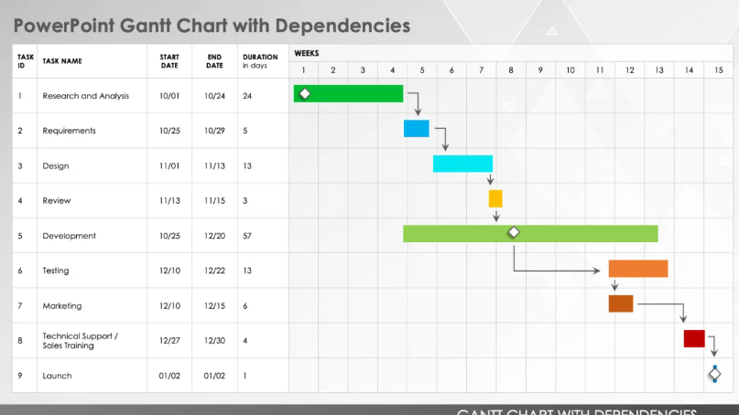

15. Task Responsibilities: Swimlane Diagram
The Swimlane Diagram below highlights responsibilities across different teams during system recovery.
Key Responsibilities:
- IT Infrastructure Team: Network Infrastructure, Kubernetes clusters.
- Integration Team: Azure Functions and Service Bus.
- Financial Team: Restore FESTINA components.
- CRM Team: Restore Salesforce platform.
- Portal Team: Restore employer and employee portals.
- BI Team: Restore reporting and analytics.

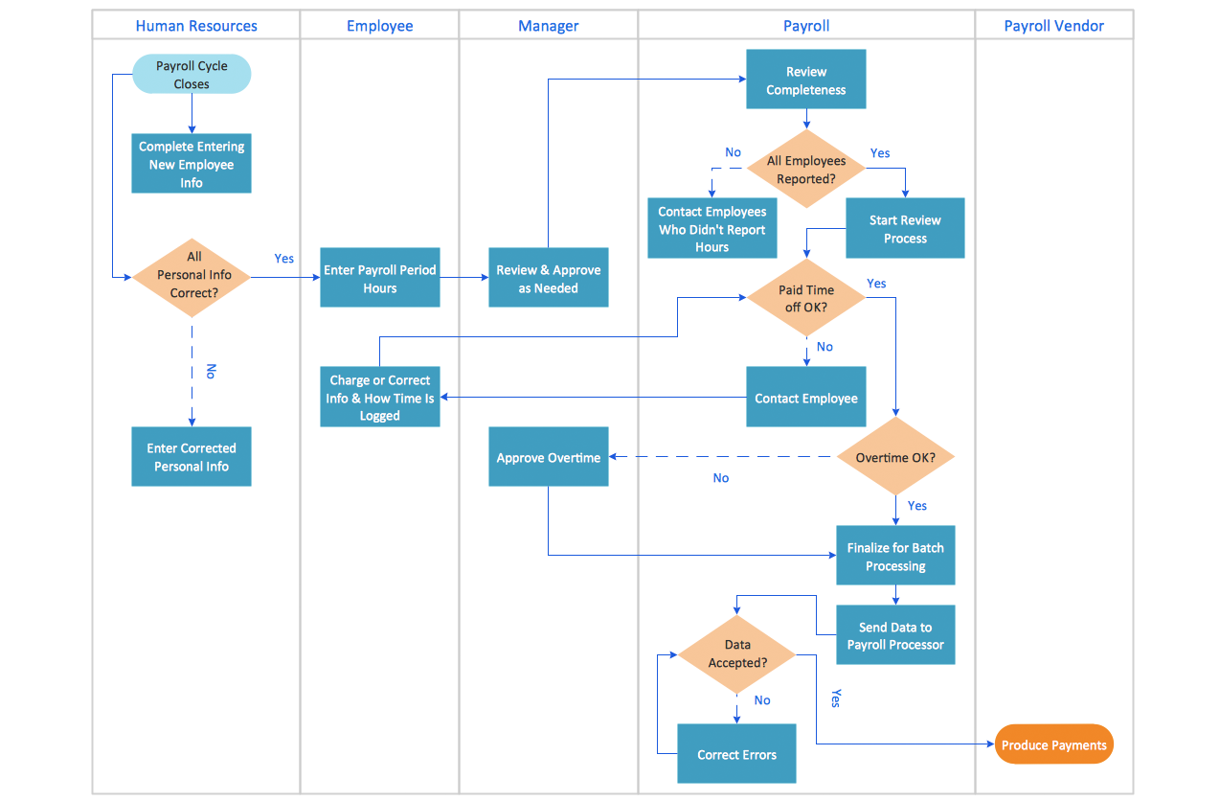

16. Responsibility Assignment Matrix (RACI Chart)
Task | Responsible (R) | Accountable (A) | Consulted (C) | Informed (I)
Restore Network Infrastructure | IT Admin | IT Manager | Cybersecurity Lead | CTO
Restore Integration Layer | Integration Lead | IT Manager | Infrastructure Admin | CTO
Restore Financial System | Financial Admin | IT Manager | Compliance Officer | CFO
Restore CRM (Salesforce) | CRM Admin | CRM Manager | Integration Lead | COO
Restore Custom Portals | Portal Team Lead | IT Manager | Integration Lead | Business Stakeholders
Restore BI Layer | BI Admin | BI Manager | Data Analyst | CEO
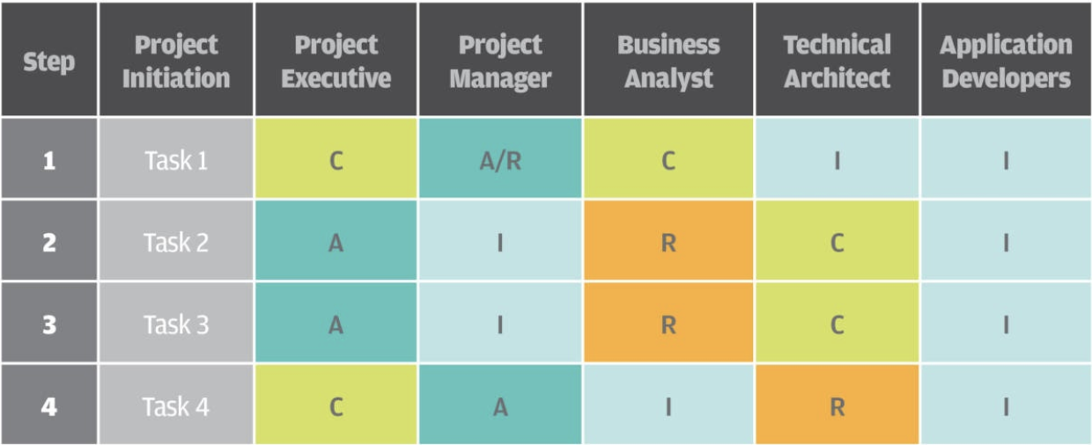

Last chapter: appendix: how-tos: how to restore the several components.

